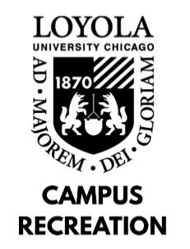

SERVICE ASSOCIATE JOB DESCRIPTION

Departmental Student Employment Philosophy: As a student employee with Campus Recreation, you will play a vital role in providing recreational and social experiences to the university community. In combination with gaining experience in interpersonal communication and conflict resolution, employment with Campus Recreation will provide you with personal and professional development sessions, leadership opportunities, and comprehensive training programs designed to enhance your self-awareness, sense of community on campus, and critical problem-solving skills.

General Position Description: The Service Associate staff is responsible for supervision of the Halas Recreation Center Front Desk and aids the Department of Campus Recreation in delivering an enjoyable experience for the Loyola Community. The Service Associate staff provides excellent customer service to members and guests at the Halas Recreation Center.

Minimum Skills and Qualifications:
- Current full time Loyola University Chicago Student
- Federal Work Study
- Ability to communicate using clear, concise, simple language
- Ability to maintain FA/CPR Certifications

Preferred Skills and Qualifications:
- Previous experience in a service position preferred

Job Duties:
- Provide the majority of daily customer service support to facility members, visitors and guests.
- Accountable for all Point of Sale operations, including selling memberships, lockers, and towel service.
- Responsible for all equipment checkout and reservations of courts (racquetball and basketball).
- Demonstrate working knowledge of Halas Recreation Center and Campus Recreation rules and regulations; ability and willingness to enforce rules and regulations.
- Assist in regular cleaning of the Halas Front Desk and storage areas.
- Attend monthly Staff Trainings and remain up to date on all American Red Cross CPR/FA skills.
- In the event of an emergency, provides emergency care and treatment as required until the arrival of emergency medical services.
Work Location and Environment:
- The majority of work is based at the Front Desk and requires little lifting

Learning Outcomes:
- Identify at least one way in which sense of community on campus has developed.
- Identify at least two ways in which communication skills have developed.
- Identify at least two ways in which problem-solving skills have developed.
- Identify at least one way in which self-awareness has developed.
- Identify at least one way in which leadership skills have developed.

